Gram Panchayat – FARIDPUR
Completion Certificate
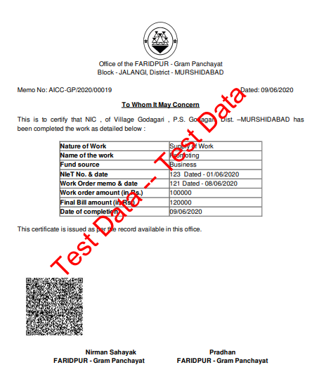

Income Certificate
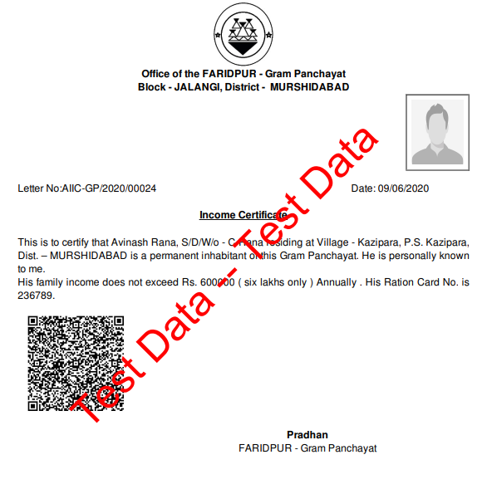

Gram Panchayat – GHOSHPARA
Residential Certificate
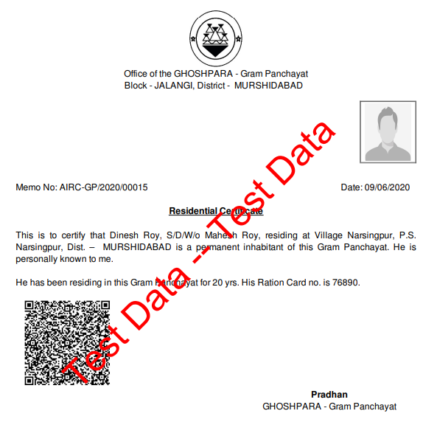

Legal Heir Certificate
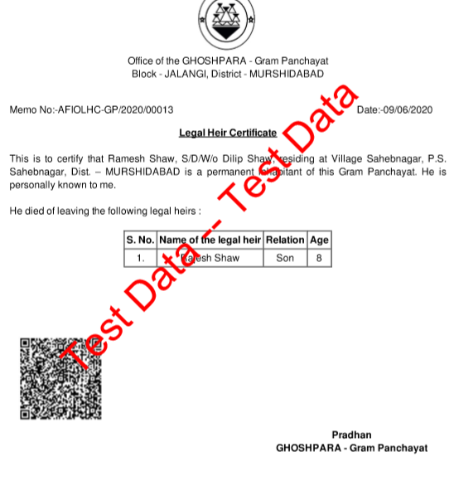

Gram Panchayat – KATABARI
Completion Certificate

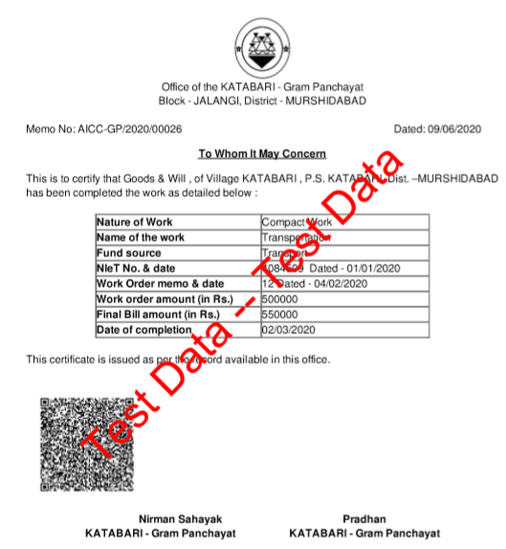

Income Certificate
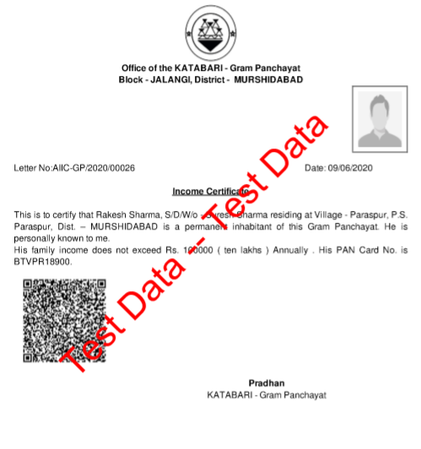

Gram Panchayat – KHAYRAMARI
Residential Certificate

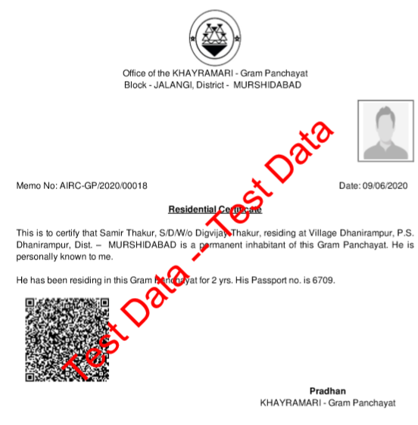

Gram Panchayat – SADIKHANDERAH
Completion Certificate
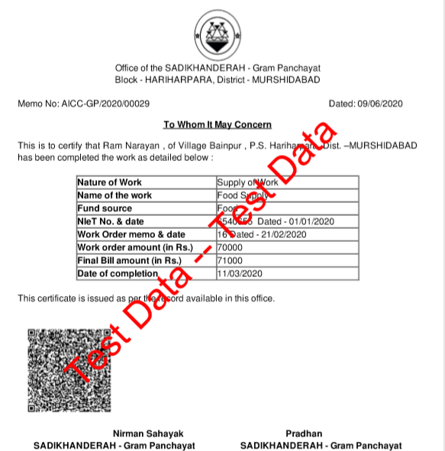

Income Certificate
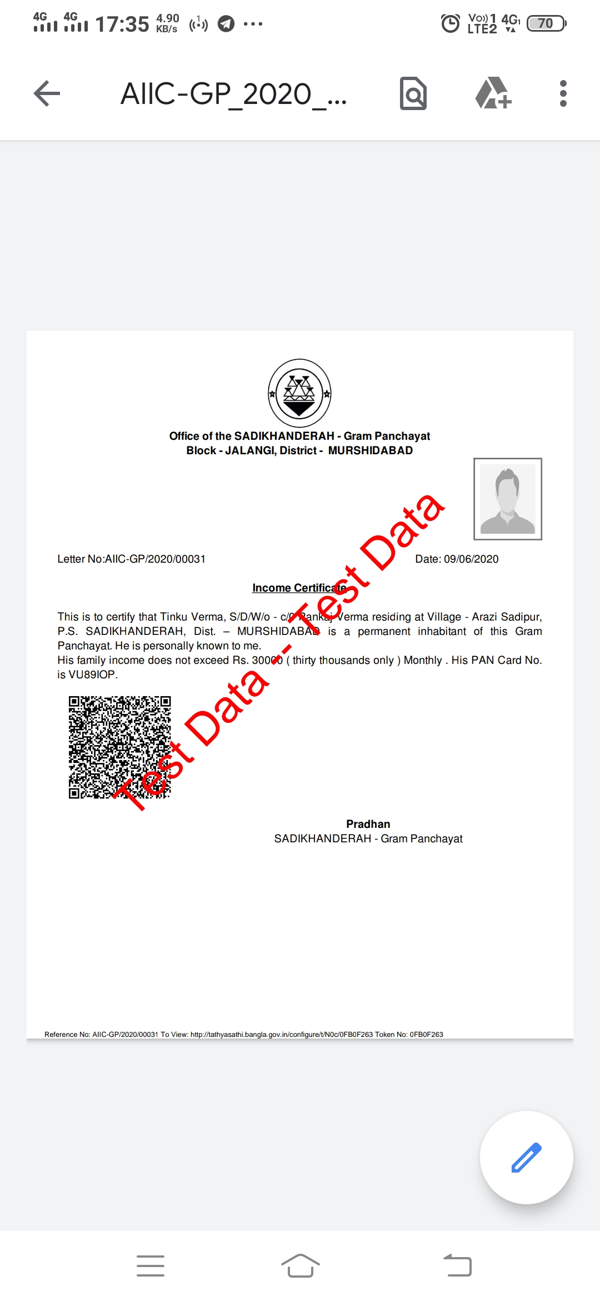

Gram Panchayat – SAGARPARA
Legal Heir
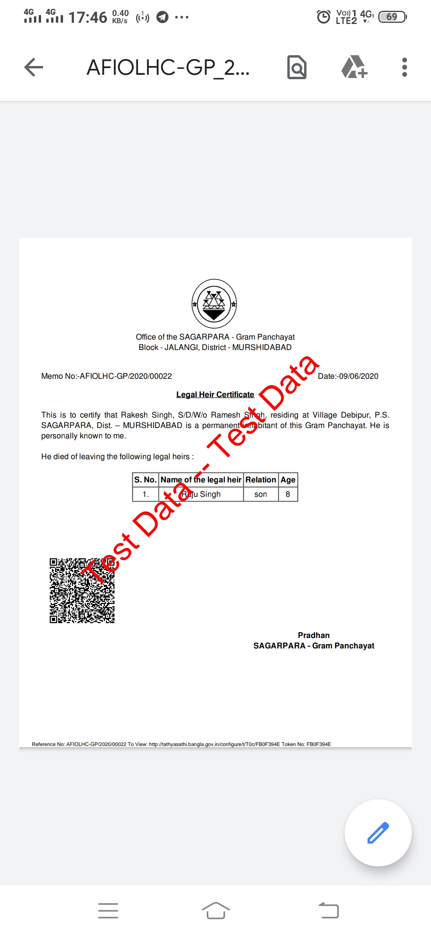

Residential Certificate
